

Lab Manual

**INTRODUCTION TO INFORMATION & COMMUNICATION TECHNOLOGY**

CSC-111

**FALL 2023**

Lab Manual

**Introduction To Information And Communication Technology**

**Semester : Fall 2023**

**Program : BSCS**

**Course Title and Name : CSC 111**

**Credits : 0+1**

**Faculty : Mehar Khan Niazi**

**Student Name :**

**Student ID :**

**Total Marks : 100**

**Obtained Marks :**

**Submitted Date :**

**TABLE OF CONTENTS**

| **Lab No.** | **Experiment Title** | **Date** | **Signature** |
| --- | --- | --- | --- |
| **1** | * Introduction to HTML * HTML program structure, Basic HTML Tags * Ordered and unordered list, Hyperlinks, Images and Tables | **fnnv** |  |

**Lab 1**

**Introduction:**

This lab will introduce you to the:

1. Hyper Text Markup Language (HTML)
2. HTML program structure, Basic HTML Tags

**Objectives:**

The purpose of this lab is to:

1. Enable students to understand the concepts of HTML, HTML program structure.
2. Introducing students to basic HTML Tags.
3. Enable students to install and use the IDE for writing HTML.

**Tools/Software Requirement:**

* Visual Studio Code
* Web Browser

**Description:**

1. **What is HTML?** 
   * A series of tags that are integrated into a text document.
   * A series of tags that are integrated into a text document.
   * These look like: <code>formatted text</code> o <code> begins the formatting tag. o </code> ends the formatting tag.
   * These tags are then read by a Browser, which translates the tags into the formatting that they represent.

1. **What are Tags?** 
   * HTML tags are used to mark-up HTML elements.
   * HTML tags are surrounded by the two characters < and >.
   * The surrounding characters are called angle brackets.
   * HTML tags normally come in pairs like <b> and </b>.
   * The first tag in a pair is the start tag; the second tag is the end tag.
   * The text between the start and end tags is the element content.
   * HTML tags are not case sensitive; <b> means the same as <B>.

1. **Structure Tags In HTML**

**HTML Tag**

**<HTML></HTML>**

These tags begin and end an HTML document.

**HEAD Tag**

<HEAD></HEAD>

These tags are in the beginning of the document. Important information is stored in- between these tags including: title, meta-data, styles, and programming scripts

**TITLE Tag**

<TITLE></TITLE>

These tags are in-between the HEAD tags and contain the text that appears in the title of the Web page.

**BODY Tag**

<BODY></BODY>

As you may have guessed, the BODY tags contain all the text in the body of the document.

1. **Block Level tags**

**4.1 HTML Headings –**

Headings are defined with the<h1> to<h6> tags.

Where <h1> -Defines the largest headings.

<h6> -Defines the smallest headings.

**4.2HTML Paragraphs -**

Paragraphs are defined with the<p> tag.

* 1. **HTML Line Breaks -**

Use the <br/> tag if you want a line break (a new line) without starting a new paragraph.

* 1. **Horizontal Rule**

The <hr> element is used for horizontal rules that act as dividers between sections

1. **HTML Text Formatting Tags**

|  |  |
| --- | --- |
| **Tag** | **Description** |
| <b> | Defines bold Text |
| <em> | Defines emphasized text |
| <i> | Defines Italic text |
| <small> | Defines italic text. |
| <strong> | Defines Strong text |
| <sub> | Defines subscripted text |
| <sup> | Defines superscripted text |
| <ins> | Defines inserted text |
| <del> | Defines deleted text |

**Download and Install Visual Studio Code (IDE / Code Editor):**

* Visit the official VS Code website: <https://code.visualstudio.com/>.

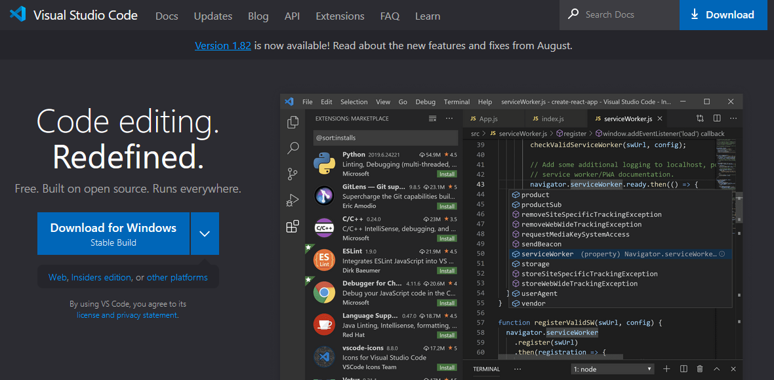

* Click on the "Download for Windows/Mac/Linux" button, depending on your operating system.

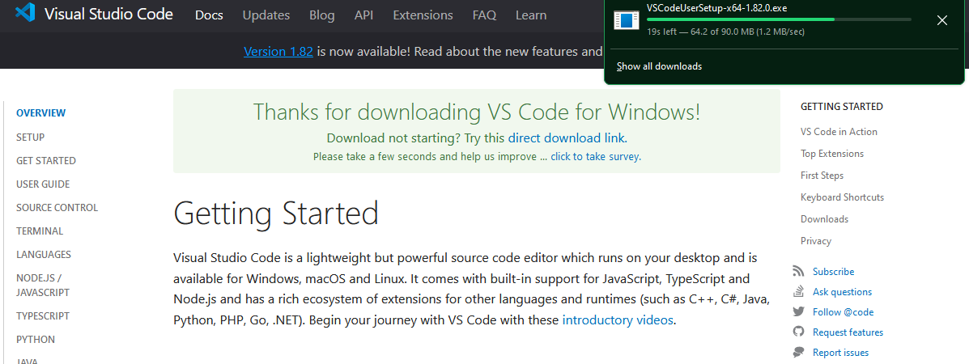

* Run the downloaded installer and follow the on-screen instructions to complete the installation. During the installation process, you can choose additional components and options as needed.

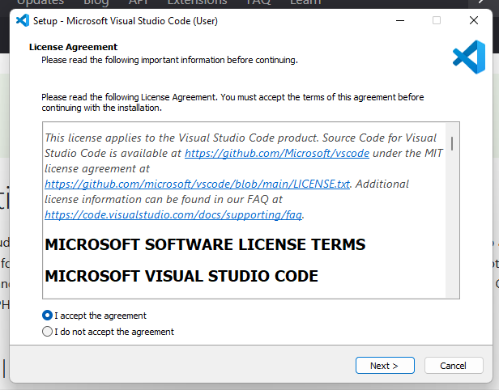

**Install Visual Studio Code Extensions:**

Extensions in VS Code enhance its functionality for specific programming languages and tasks. To set up VS Code for HTML development, follow these steps:

* Open Visual Studio Code after installation.
* On the left sidebar, you'll find the Extensions icon (a square-shaped icon with four small squares). Click on it.

In the Extensions view, search for and install the following extensions:

* **HTML Language:** This extension provides HTML language support, including auto-completion and syntax highlighting.
* **Live Server:** Live Server is a popular extension that allows you to create a local development server and view your HTML files in a web browser. It provides real-time updates as you edit your HTML.
* **Auto Close Tag:** This extension automatically adds closing HTML tags when you type an opening tag.
* **Auto Rename Tag:** It automatically renames paired HTML tags when you edit one of them.
* **Prettier - Code formatter:** Prettier is a code formatter that helps maintain consistent code formatting in your HTML and other code files.

* **HTML Snippets:** This extension provides a collection of HTML snippets for quickly generating HTML code.
* **Emmet:** Emmet is a powerful tool for HTML and CSS, allowing you to write code faster using shortcuts and abbreviations.

**Create a New HTML File:**

* Open VS Code.
* Click on "File" in the top menu, then select "New File" to create a new, empty file.
* Save the file with an .html extension (e.g., index.html). Choose a location on your computer to save it.

**Writing and Previewing HTML Code:**

* In the newly created .html file, you can start writing your HTML code. VS Code provides code suggestions and auto-completion to help you write code more efficiently.
* To preview your HTML page, right-click on the file tab (e.g., index.html) and select "Open with Live Server." This will open your HTML file in your default web browser.
* As you make changes to the HTML file and save them in VS Code, the Live Server extension will automatically refresh the browser, allowing you to see real-time updates.

**Saving and Closing Files:**

* Save your work frequently by pressing Ctrl + S (Windows/Linux) or Cmd + S (Mac).
* To close a file, click on the file tab and select the "Close" option.

**Exiting Visual Studio Code:**

To exit Visual Studio Code, click on the "File" menu and select "Exit" (Windows/Linux) or click on the "Code" menu and select "Quit Visual Studio Code" (Mac).

**Lists, Hyperlinks, Images, and Tables:**

**Ordered and Unordered Lists:**

HTML provides two main types of lists: ordered and unordered. Ordered lists are numbered, while unordered lists are bulleted. These lists are created using the <ol> (ordered list) and <ul> (unordered list) elements, respectively. Each list item is enclosed in <li> (list item) tags.

**Example:**

<ol>

<li>Item 1</li>

<li>Item 2</li>

<li>Item 3</li>

</ol>

<ul>

<li>Item A</li>

<li>Item B</li>

<li>Item C</li>

</ul>

**Hyperlinks:**

Hyperlinks, also known as links, allow you to navigate between web pages. You create hyperlinks using the <a> (anchor) element and the href attribute to specify the destination URL.

**Example:**

<a href="https://www.example.com">Visit Example</a>

**Images:**

Images enhance the visual appeal of web pages. To insert an image in HTML, use the <img> element with the src attribute pointing to the image file and the alt attribute for alternative text.

**Example:**

<img src="image-url.jpg" alt="Description of the image">

**Tables:**

Tables are used to organize data in rows and columns. To create a table, use the <table> element. Within the table, use <tr> for table rows, <th> for table headers (usually the first row), and <td> for table data cells.

**Example:**

<table>

<tr>

<th>Header 1</th>

<th>Header 2</th>

</tr>

<tr>

<td>Data 1</td>

<td>Data 2</td>

</tr>

</table>

**LAB TASKS**

**Task 1:**

Create Your First HTML Document

* Open a text editor (e.g., Notepad, Visual Studio Code).
* Create a new HTML file and name it "index.html."
* Write the basic HTML structure
* Save the file and open it in a web browser to view your first HTML page.

Code:

<!DOCTYPE html>

<html>

<head>

    <title>Coding</title>

</head>

<body>

</body>

</html>

output:

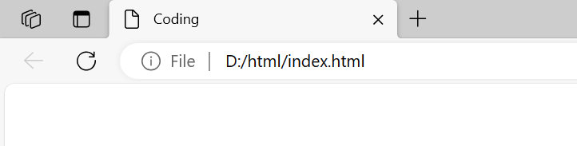

Reason/explanation:

Created index file with the extension of html to write a basic html structure which includes a declaration of html file called DOCTYPE and it is very important to declare this first before writing any html program because it tells browser which version of html is being used. Then the first and most important html tag is created then its head tag which contains title tag inside of it and then after head we create body tag to write the code to create the structure of the website.

**Task 2:**

Explore Basic HTML Tags

* Open the "index.html" file you created in the previous task.
* Add the follow HTML tags inside the <body> element:
  + <h2> for a subheading.
  + <p> for a paragraph of text.
  + <em> for emphasized text.
  + <strong> for strong text.
  + <a> for a hyperlink to any website.
* Add content and attributes to each tag to see how they affect the display.
* Save the file and refresh it in your web browser to see the changes.

Code:

<!DOCTYPE html>

<html>

<head>

    <title>Coding</title>

</head>

<body>

    <h2>Pakistan</h2>

    <p><em>Pakistan is a country in south asia and it is the world's <strong>fifth-most</strong> populous country, with a population of 241.5 million people.</em>

    <br>

    <a href="https://pakistan.gov.pk/">this is pakistan's official goverment link </a>

    </p>

</body>

</html>

output:

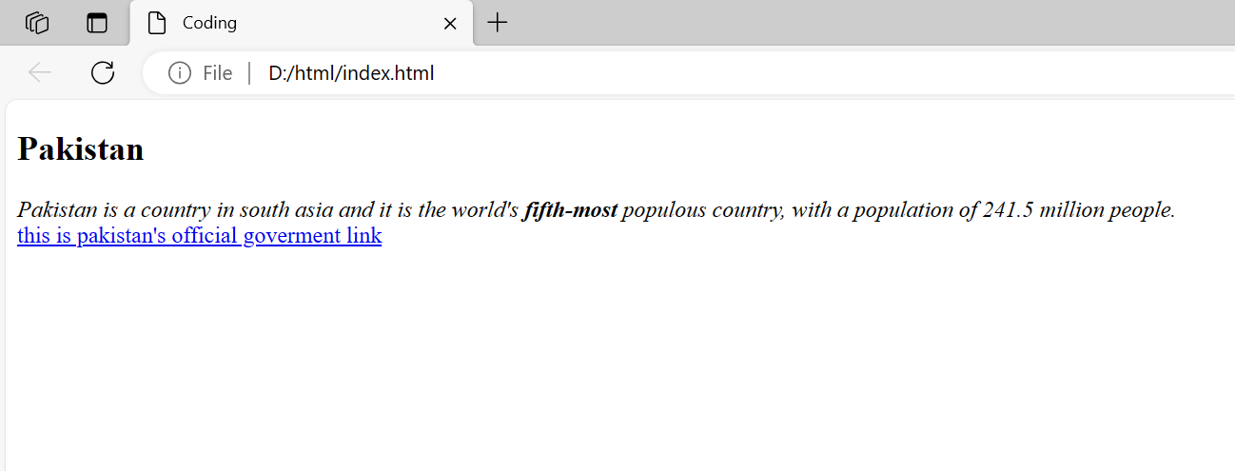

Reason/explanation:

In this code we have used basic html tags such as heading tag (<h1>), writing tag (<em>), paragraph tags(<p>) and many others to write the text and to add a link to a website we have use <a> tag inside it used href to add the link.

**Task 3:**

Create Lists

* Create a new HTML file named "lists.html."
* Create an ordered list (OL) with three items, such as your top three hobbies.
* Create an unordered list (UL) with three items, such as your favorite movies.
* Save the file and open it in a web browser to see the lists.

Code:

<!DOCTYPE html>

<html>

<head>

    <title>List</title>

</head>

<body>

    <h2>My hobbies</h2>

    <ol>

        <li>baking</li>

        <li>reading books</li>

        <li>sleeping</li>

    </ol>

    <h2>My favourite books</h2>

    <ul>

        <li>The Alchemist</li>

        <li>Atomic habits</li>

        <li>It ends with us</li>

    </ul>

</body>

</html>

Output**:**

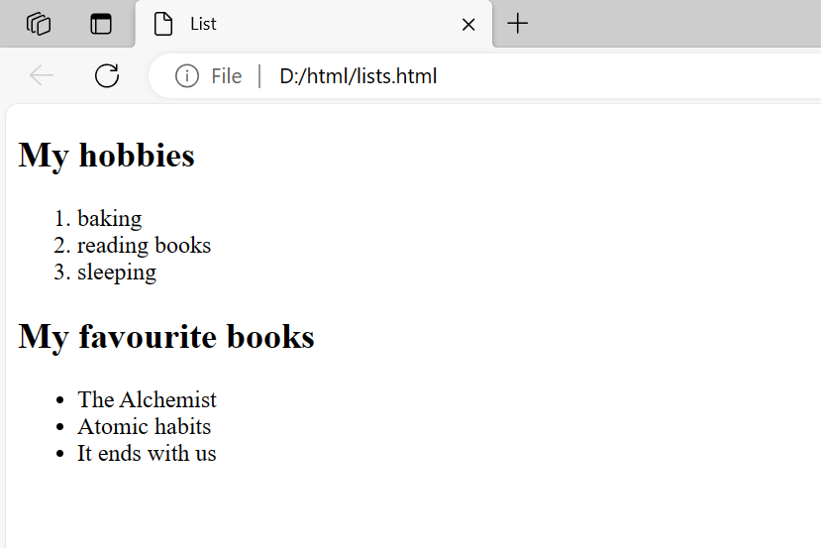

Reason/explanation:

In this code we have created two lists first one is ordered list created with a tag <ol> and inside it used <li> tag to add items to the list same as we have created unordered list but in place of <ol> in unordered list we use <ul>.

**Task 4:**

Add Hyperlinks

* Continue editing the "lists.html" file.
* Create a new section and add hyperlinks to your favorite websites using the <a> element.
* Ensure each link has a suitable text description and uses the href attribute.
* Save the file and test the hyperlinks in your web browser.

Code:

<!DOCTYPE html>

<html>

<head>

    <title>List</title>

</head>

<body>

    <h2>My hobbies</h2>

    <ol>

        <li>baking</li>

        <li>reading books</li>

        <li>sleeping</li>

    </ol>

    <h2>My favourite books</h2>

    <ul>

        <li>The Alchemist</li>

        <li>Atomic habits</li>

        <li>It ends with us</li>

    </ul>

    <h2>My favorite websites</h2>

    <ol>

        <li><a href="https://problogger.com/">ProBlogger</a><br>ProBlogger was founded by Darren Rowse. It has been the home for bloggers wanting to create and grow their blogs.</li>

        <li><a href="https://www.fandom.com/">Fandom</a><br>Fandom is the world's largest entertainment & gaming fan platform.</li>

    </ol>

</body>

</html>

Output:

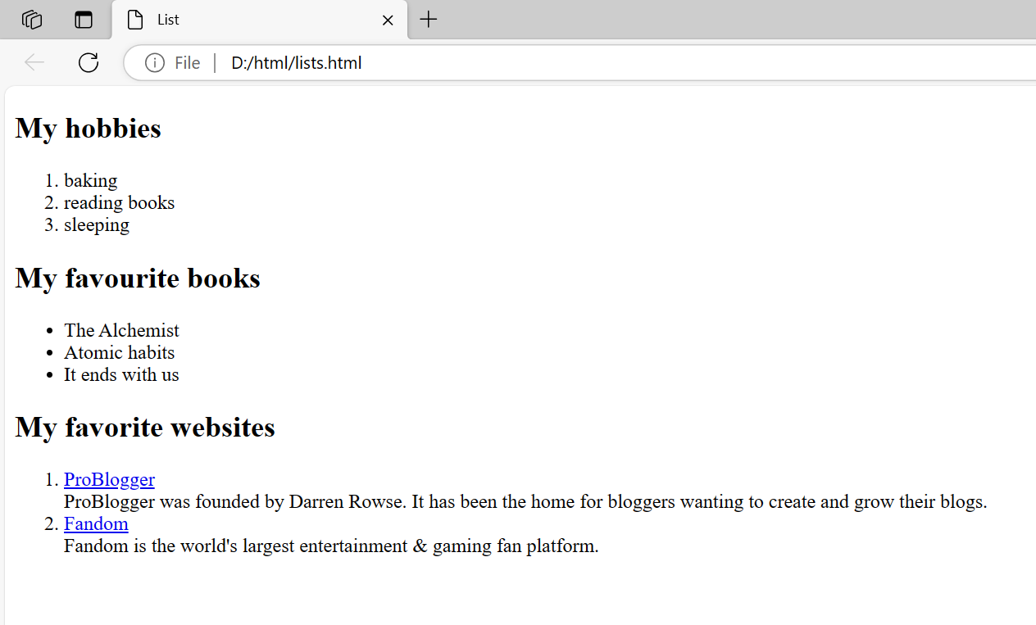

Reason/explanation:

In this task we have continued from the previous task and added some more properties of html. Here we have added the links to two websites using <a> tag inside it used href to add link.

**Task 5:**

Insert Images

* Continue editing the "lists.html" file.
* Create another section and insert images using the <img> element. Use placeholder image URLs if needed.
* Add the alt attribute with a description for each image.
* Save the file and view how the images are displayed in the browser.

Code:

<!DOCTYPE html>

<html>

<head>

    <title>List</title>

</head>

<body>

    <h2>My hobbies</h2>

    <ol>

        <li>baking</li>

        <li>reading books</li>

        <li>sleeping</li>

    </ol>

    <h2>My favourite books</h2>

    <ul>

        <li>The Alchemist</li>

        <li>Atomic habits</li>

        <li>It ends with us</li>

    </ul>

    <h2>My favorite websites</h2>

    <ol>

        <li><a href="https://problogger.com/">ProBlogger</a><br>ProBlogger was founded by Darren Rowse. It has been the home for bloggers wanting to create and grow their blogs.</li>

        <li><a href="https://www.fandom.com/">Fandom</a><br>Fandom is the world's largest entertainment & gaming fan platform.</li>

    </ol>

    <h2>Image</h2>

    <img src="image/nasa.jpeg" width="200" heigth="200">

    <br>"Nasa's Man on the Moon"

</body>

</html>

Output:

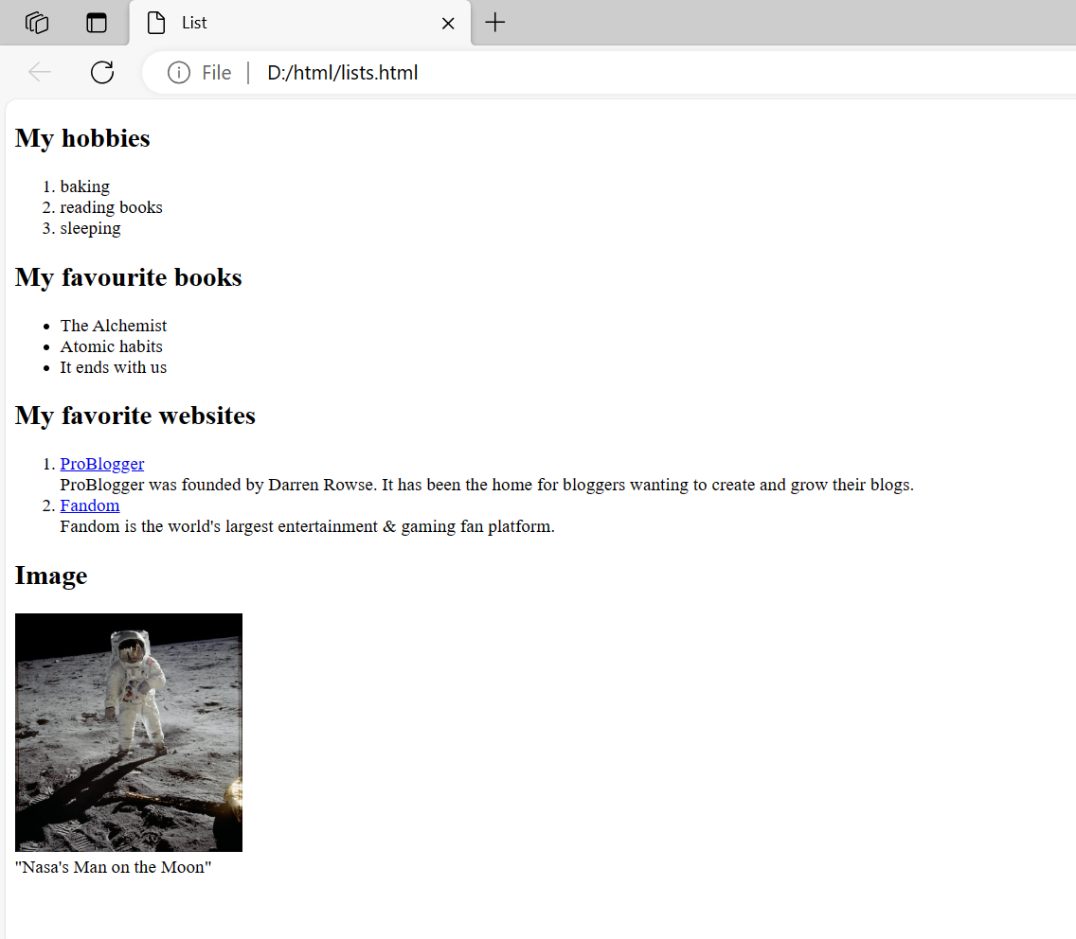

Reason/explanation:

Continued from previous code here we have added the image to the website using <img> tag and inside it we have use src to add the link of the image. With that we have also added distription to the image.

**Task 6:**

Create a Table

* Continue editing the "lists.html" file.
* Create a table with at least three rows and three columns.
* Include headers in the first row using the <th> element.
* Populate the table with data using the <td> element.
* Save the file and examine the table layout in your web browser.

Code:

<!DOCTYPE html>

<html>

<head>

    <title>List</title>

</head>

<body>

    <h2>My hobbies</h2>

    <ol>

        <li>baking</li>

        <li>reading books</li>

        <li>sleeping</li>

    </ol>

    <h2>My favourite books</h2>

    <ul>

        <li>The Alchemist</li>

        <li>Atomic habits</li>

        <li>It ends with us</li>

    </ul>

    <h2>My favorite websites</h2>

    <ol>

        <li><a href="https://problogger.com/">ProBlogger</a><br>ProBlogger was founded by Darren Rowse. It has been the home for bloggers wanting to create and grow their blogs.</li>

        <li><a href="https://www.fandom.com/">Fandom</a><br>Fandom is the world's largest entertainment & gaming fan platform.</li>

    </ol>

    <h2>Image</h2>

    <img src="image/nasa.jpeg" width="200" heigth="200">

    <br>"Nasa's Man on the Moon"

    <p>

        <table>

            <tr>

                <th>StdName</th>

                <th>Marks</th>

                <th>TotalMarks</th>

            </tr>

            <tr>

                <td>Ali</td>

                <td>45</td>

                <td>50</td>

            </tr>

            <tr>

                <td>bilal</td>

                <td>42</td>

                <td>50</td>

            </tr>

            <tr>

                <td>janta</td>

                <td>48</td>

                <td>50</td>

            </tr>

        </table>

    </p>

</body>

</html>

Output: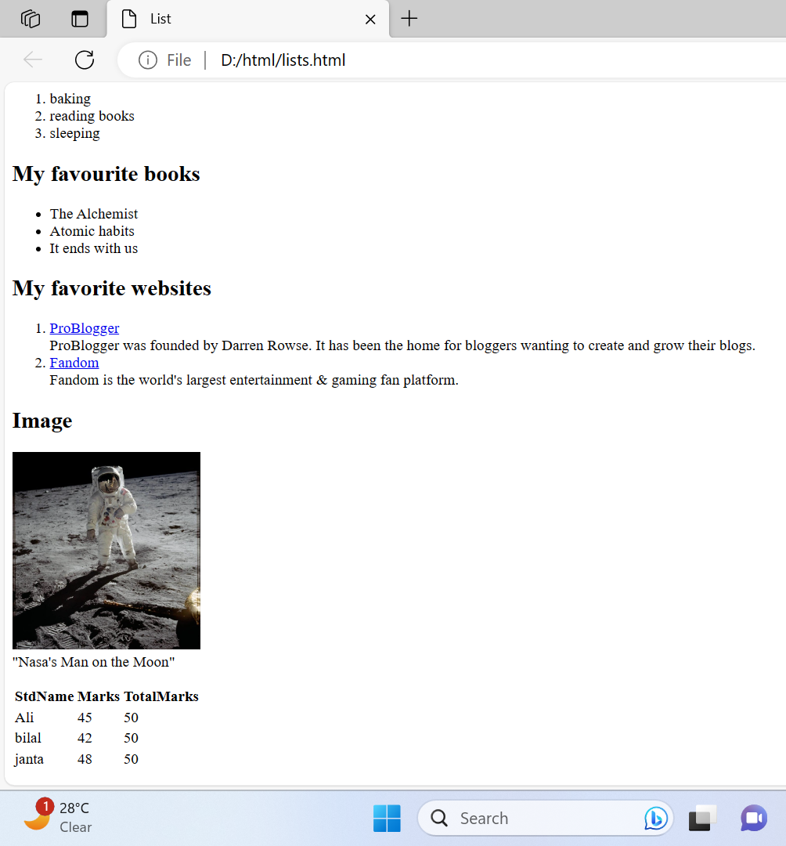

Reason/explanation:

Here we have added a table to the previous code using tags such as <table></table> and inside this we have used table header and table rows tags to add items.

**Task 7:**

Make use of all the tags discussed in this lab and make a webpage.

Code:

<!DOCTYPE html>

<html>

<head>

    <title>SanjBlog.com</title>

</head>

<body>

    <p><b>Today's topic of blog will be about my most favourite book that is <strong>"ATOMIC HABITS"</strong></b></p>

    <h1><em>Why a person should ready book <b>"Atomic Habits"</b></em></h1>

    <p>

        <img src="image/atomic.jpg" width="200" height="150">

        <br>

        James Clear's self-help book "Atomic Habits" discusses how little, enduring adjustments can result in substantial personal and professional improvement.

    </p>

    <p>

        <img src="image/a1.jpg" width="200" height="200">

        <img src="image/a2.jpeg"  width="200" height="200">

        <br>

        "Reading Atomic Habits offers <b>valuable</b> insight into the science of habit formation and practical strategies for positive change. James Clear's approach empowers people to transform their lives through small, lasting changes. The book provides a road map for breaking bad habits and building good habits . and achieving meaningful goals. It is a powerful tool for personal development, productivity and creating sustainable and positive changes."

    </p>

    <p>

        <img src="image/download.png" width="200" height="100">

        <br>

        "Atomic Habits" is a beacon of hope for those seeking lasting change in their lives. James Clear's systematic approach to habit formation empowers readers to embrace the power of small, consistent actions that ultimately lead to massive change.

    </p>

</body>

</html>

Output: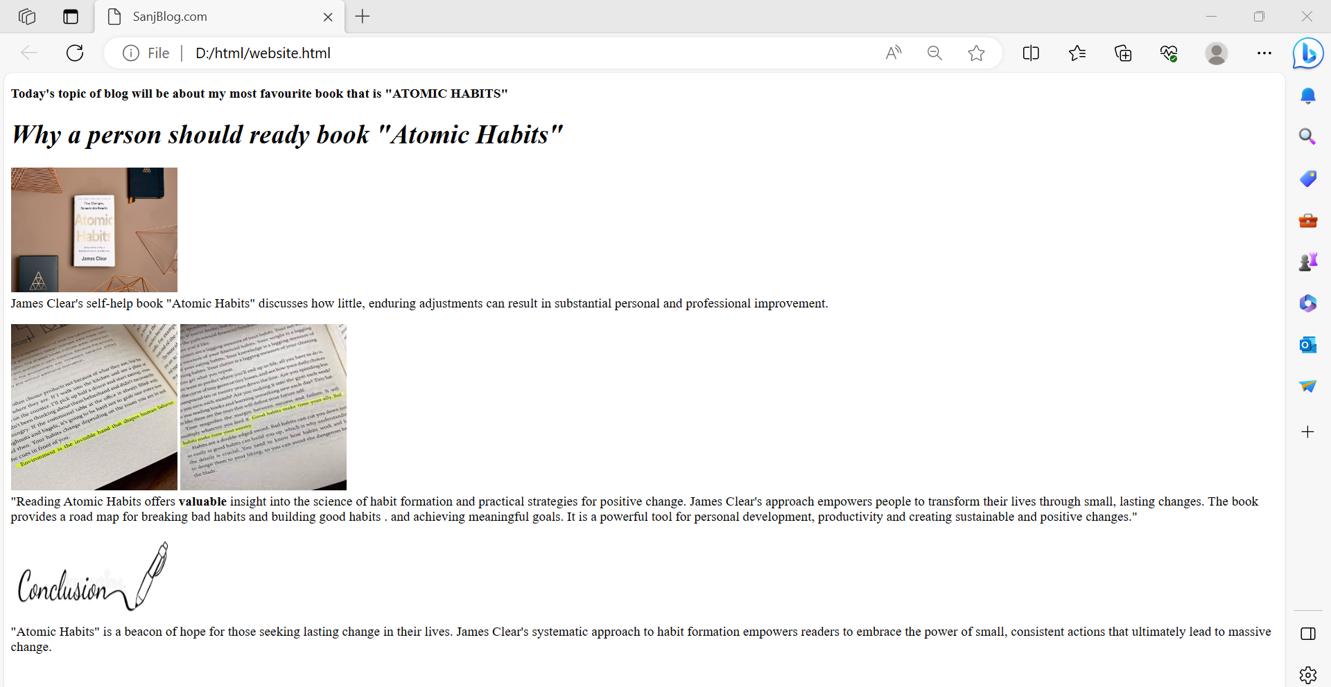

Reasons/explanation:

Here we have made the structure of personal blog webpage using html only. Here we have used different tags such as heading, writing, paragraphs and many more to edit the text written in the blog. And added images using image tags.